# **Day 6: Deployment Preparation and Staging Environment Setup**

**Overview:**  
On Day 6, we prepared the marketplace for deployment by setting up a staging environment and streamlining the deployment pipeline. We focused on deployment tests, backend refinements, performance optimization, and cross-browser compatibility to ensure the platform is efficient, secure, and production-ready.

# **Performance optimizations**

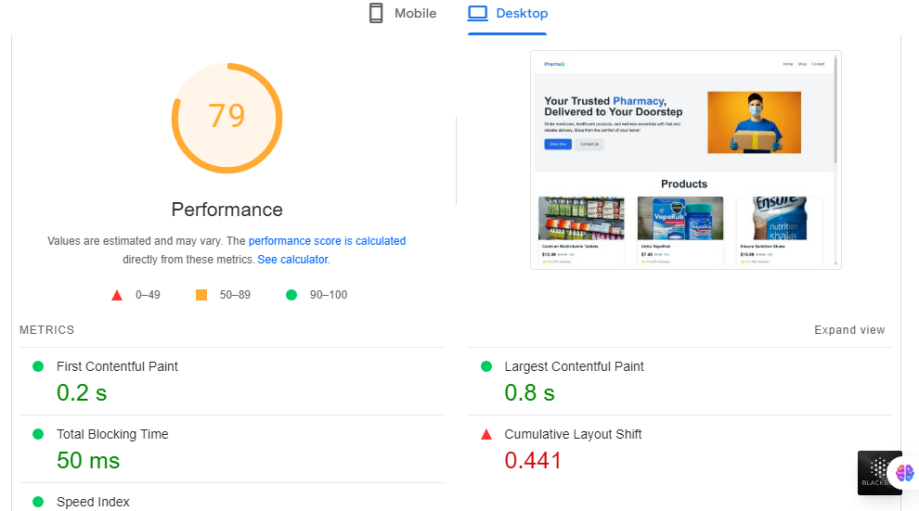

# **Deployed using Vercel**

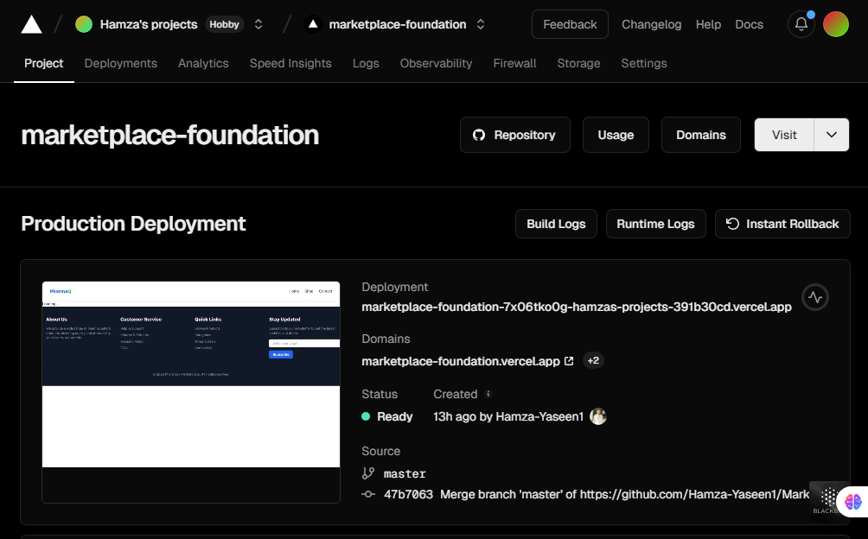

# **Security measures**

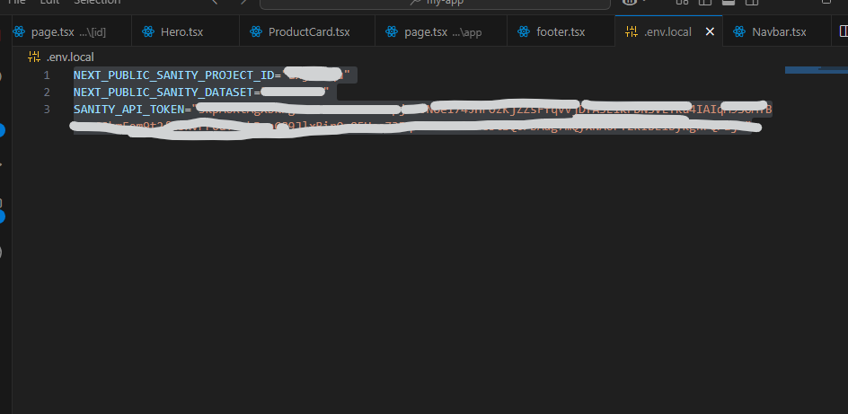

# **Backend integrations**

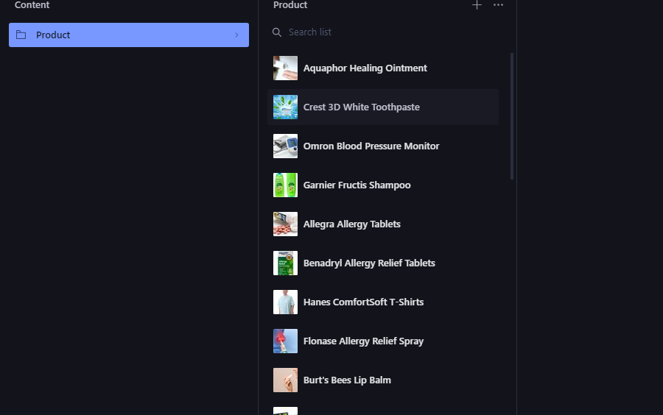

# **Testing**

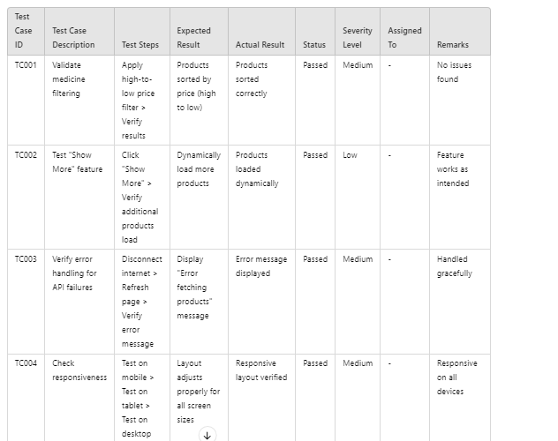

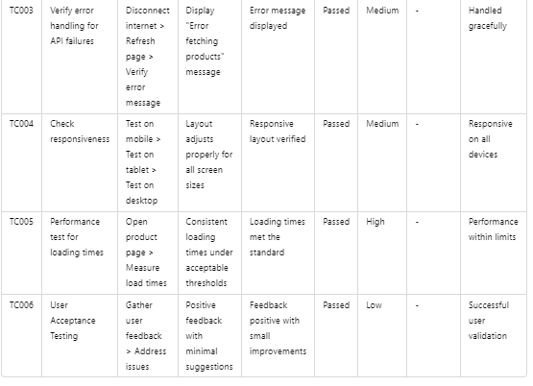

**Day 6 Summary**  
On Day 6:

1. Set up a staging environment on Vercel to simulate production.
2. Deployed the marketplace to staging and tested core features.
3. Optimized backend performance for scalability under high traffic.
4. Tested functionality across browsers (Chrome, Brave) and devices (mobile, tablet, desktop).
5. Documented the deployment process for easy future transitions.